W413 Water Vapor Permeability Analyzer

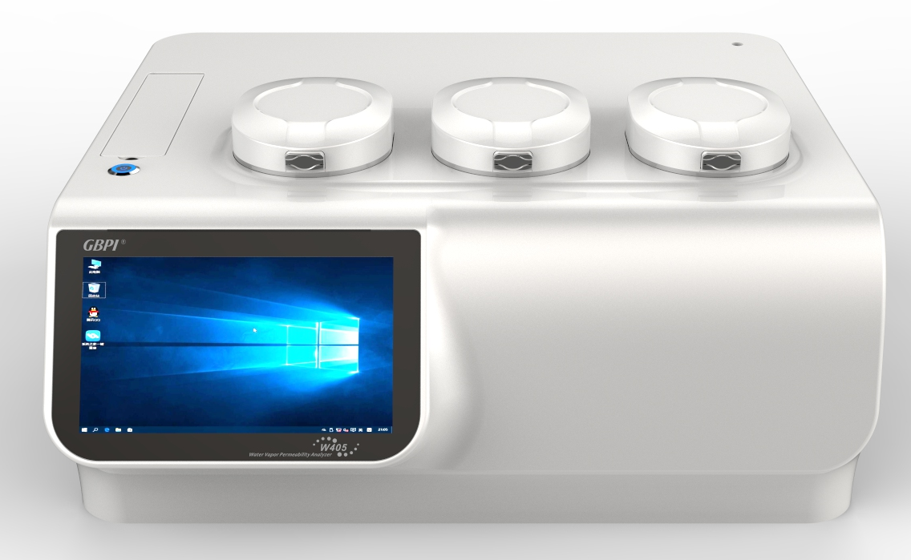

Application
W413 water vapor permeability analyzer is designed to test the water vapor transmission rate (WVTR) of films or sheets materials.
Applied to:
1) Plastic film, composite film, aluminum foil, aluminized film, etc;
2) Sheet, panel, rubber, ceramics, etc;
3) Packaging containers, such as: glass, bottle, cans, boxes, etc;
4) Expanding application: solar panel, LCD film, medical patch, etc.
Widely used in quality inspection organizations, drug control institutions, research institutes, packaging, thin film, food companies, pharmaceutical enterprises, personal care industry, electronics industry and so on.

Standard
GB/T 26253-2010，YBB 00092003-2015，BS EN ISO 15106-2-2005，ASTM F1249-2013，JIS K7129-2008
Specification
Item | Technical parameters
Test range | 0.002~1000 g/m²·24h（film and sheet）
Test precision | 0.001 g/m²·24h（film and sheet）
Temperature range | 15~45℃（15~60℃ optional）
Temperature accuracy | ±0.1℃
Humidity range | 0%, 30~90%RH，100%RH
Humidity accuracy | ±1%RH
Test area | 50.24 cm²（with additional adapting piece and be small as 0.785 cm² ）
Sample size | Φ100 mm
Sample thickness | ≤3mm
Number of test sample | 1~3 pieces
Carrier gas | 99.999% N₂（user provide）
Carrier gas pressure | ≥0.1MPa
Carrier gas flow | 5~100 mL/min
Pneumatic pressure | ≥0.3MPa
Instrument size | 700×560×370mm
Weight | 80kg
Power | 750W
Power supply | AC 220V，50Hz

Features
- Accurate and reliable data
- With The State Certificate for Gradation of the certified Reference Materials and Licence for Manufacturing Measuring Instruments of the state Reference Materials（GBW(E)130543/4）of Water Vapor Permeability Analyzer approved and issued by General Administration of Quality Supervision, Inspection and Quarantine of the P.R.C. Adopting state reference materials to calibrate and verify the instruments, ensure the accuracy, universality and authority of the test data.

- Simple operation
- Professional software with simple interface, easy to use and convenient to set test process.
- Fully-auto operation, one-button test, judge and stop automatically.
- Curves display of permeability volume, flow rate, voltage, temperature and humidity in real time. The curves with conceal function, support query function for background data.
- Mainframe configure with color touch screen, can observe temperature, humidity and transmission without external computer.
- Professional test report can be automatically generated and exported in PDF format.

- Advanced technology
- Temperature control: International advanced electromagnetic program step temperature control technology, auto heating and cooling; no need of external accessories. Precision: 0.1℃.
- Humidity control: Dual gas flow method (dry gas and humid gas), high precision (1%RH) and constant humidity.
- Supports electronic signature, online report submission, auditing function.

- High efficiency
- Three independent test chambers: With three sensors and each chamber test independently, three same/different samples can be tested at the same time and output three test reports, which improve test efficiency.
- With three different test modes of high, medium and lower barriers, can test films with different barrier property.
- Measurement precise up to 0.001 g/m²·24h, can test high barrier materials, such as aluminum foil.

- Authority management & data trace
- The software is designed according to the requirements of the new GMP Appendix computerized system.
- Need a user name and password to log in to the workstation, and ensure the safety and effectiveness of account and experiment data.
- Users can be classified into different levels of system administrator, instrument administrator, auditor and operator.
- The system administrator can adjust the permissions of various levels, for example, increase and decrease system control items of any level.
- Have audit and trace functions (test tracking, log tracking), every data change is recorded, ensure the security and integrity of test data.

- Reliable and easy-maintenance instrument
- Imported infrared sensor, with high precise and good performance, can work for a long time.
- Sensor over-range automatic protection, prevent damaging important sensors while instrument failure.
- Functional modular design, easy to maintain.

Note: GBPI is always committed to product innovation and improved performance, so accordingly product technical specifications are subject to change without notice. GBPI reserves the right to amend and the final power of interpretation.

